**✅ Final Project Report**

**Course**: Programming II (Section 2)  
**1st Student Name**: Salih Artuç  
**1st Student ID**: 23040102018

**2nd Student Name**: Yusuf Eren Şerbetçi  
**2nd Student ID**: 23040102024  
**Project Title**: Card Matching Game

**🔹 Project Description**

This project is a two-player memory matching game implemented using Java, JavaFX, and CSS. The application starts with a login/registration panel where users can register and log in. It features input validation with character length restrictions.

After successful login, the user is directed to the main menu, which offers options to start the game, view scores, or log out. Upon clicking “Play Game,” the player selects the grid size: 3×4, 4×4, or 4×5. Then, both players must enter nicknames (between 3 to 8 characters), with empty or invalid inputs blocked.

In the gameplay screen:

* A score box at the top shows the current scores of Player 1 and Player 2.
* There are buttons for restarting the game and returning to the main menu.
* The background color changes depending on the active player.
* Cards stay open for 1 second after being clicked for better visibility.
* Clicking already matched or currently open cards is disabled.
* Cards are shuffled randomly on each game start.
* Matched cards turn green to visually indicate success.
* When the game ends, a game-over screen shows the final scores and the winner, along with buttons to return to the main menu or view score history.

The **Scores** section stores and displays past games with player names, scores, and dates.

**🔹 Unique Features**

* Dynamic background color based on active player
* Grid size selection (3×4, 4×4, 4×5)
* Cards visually turn green on match
* Game data including date and players is stored and displayed
* End-game screen with score summary and navigation

**🔹 GitHub Repository**

🔗 https://github.com/Salih-artuc/JavaProject-Card-Matching-Game

🔗 https://github.com/YusufErenSerbetci/Card-Matching-Game-Project

**🔹 Installation Guide**

1. Clone or download the project from the GitHub repository.
2. Open the project in Eclipse or IntelliJ as a Maven project.
3. Make sure Java 17 and JavaFX 20 are installed.
4. Run the Main.java file to start the application.

**🔹 Images**

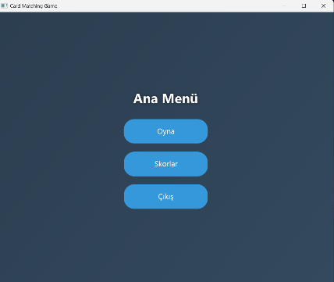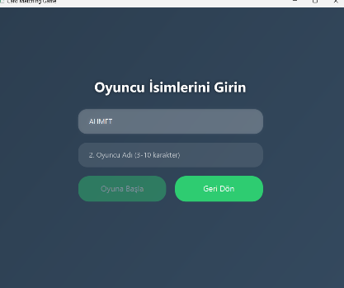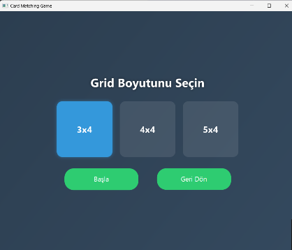

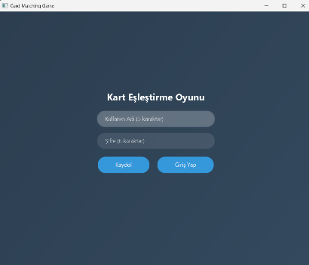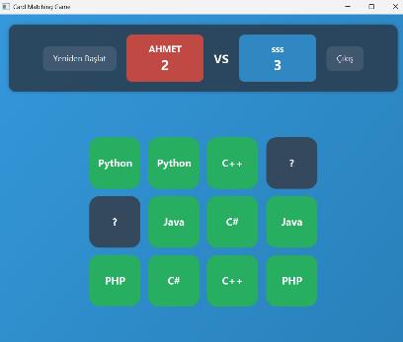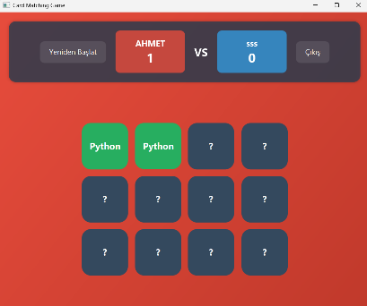

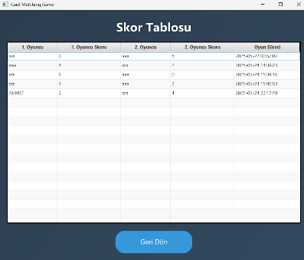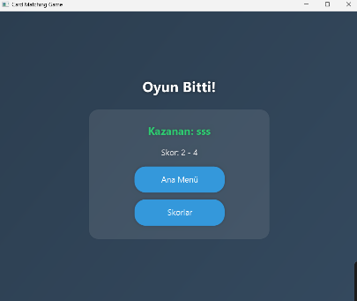

|  |  |  |
| --- | --- | --- |
| **Feature** | **Successfully realized (Yes or No)** | **Source code file names** |
| Basic functionality | Yes | GameController.java |
| Authentication | Yes | LoginController.java |
| File processing | Yes | ScoresController.java LoginController.java |
| **Additional features (if any):** |  |  |
| Background Color Change | Yes | GameController.java |
| Game Date Tracking | Yes | ScoresController.java |
| Grid Size Selection | Yes | GridSelectionController.java |
| Visual Feedback on Match (green) | Yes | GameController.java |
| Game Over Screen & Navigation | Yes | GameOverController.java |